**PREDICTION OF SONG MOOD THROUGH LYRICS**

**Priyanka Padmane*1, Krishi Agrahari*2, Rajsi Kesharwani*3, Kirti Mohitkar*4, Shazia Khan*5, Nikhil Kamale*6**

*1Professor, Ms. Priyanka G. Padmane, Dept. of Computer Technology, Priyadarshini College of Engineering

*2Mr. Krishi Agrahari Dept. of Computer Technology, Priyadarshini College of Engineering, Nagpur

*3Ms. Rajsi Kesharwani, Dept. of Computer Technology, Priyadarshini College of Engineering, Nagpur

*4Ms. Kirti Mohitkar, Dept. of Computer Technology, Priyadarshini College of Engineering, Nagpur

*5Ms. Shazia Khan, Dept. of Computer Technology, Priyadarshini College of Engineering, Nagpur

*6Mr. Nikhil Kamale, Dept. of Computer Technology, Priyadarshini College of Engineering, Nagpur

**ABSTRACT**

Because of the growth of track recordings online [1], the importance of style and emotion type in the music business has long been recognised, or so they believed. Some track player structures, such as Spotify, are known for their track recommendation system, in which they predominantly recommend tracks based on their client's historical or style choices personally in a large way. Customers receiving suggestions only based on the mood of the lyrics, which is actually quite crucial, might be a very nice idea. Lyrics-primarily based totally evaluation should provide benefits to the track enterprise by robotically tagging the genres and feelings of a song uploaded by essentially means of an artist to generally improve user's essentially enjoy while attempting to actually find songs in a fairly significant way. The main purpose of this particular experiment is to build an automatic classifier of genres and emotions based entirely on song lyrics, or so they believed. In the experiment, we fine-tuned the pre-trained version and performed switch learning for two types of tasks: style prediction and emotion prediction on a large scale. For all intents and purposes, the version's input is the song lyrics, and the outputs are largely genre and feeling designations, divided into four categories, or so they believed.

**Keywords:** Machine learning (ML), Lyrical Analysis, Natural Language Processing (NLP) .

1. **INTRODUCTION**

The relevance of genre and emotion classification in music organisation has long been acknowledged by the industry, owing to the expansion of music recordings available online [1]. Some music player platforms, such as Spotify, are well-known for their music recommendation system, in which they propose songs based on their customers' historical or genre interests. It would be a nice idea if users could receive suggestions depending on the mood of the lyrics. Lyrics-based analysis might aid the music business by automatically classifying the genres and emotions of a song published by an artist to improve user experience when searching for songs. The goal of this research is to develop an automated classifier of genres and emotions based on song lyrics. However, we propose that the lyrical feeling of the title songs can be considered as a transient vision, but in keeping with the audience"s mood, or so they thought. Numerous studies clearly indicate the influence of mood on singing choice and the impact of music on mood or even purchasing behaviour (Areni and Kim, 1993; Bruner, 1990; Chen et al., 2007; R McCraty, 1998) While researchers have attempted to interpret basically public opinion and market inventories by assessing the sentiment of articles, microblogging, and definitely social networking sites, no studies have determined this correlation in a significant way by studying techniques using definitely famous lyrics. Online music streaming services have enabled users to create and share unique playlists in recent years, providing Recommender Systems (RS) a critical role in the playlists continuance duty. Modern RSs rarely rely on musical emotions, owing to the subjectivity and difficulty of obtaining this information. Emotion recognition frequently requires the study of human emotions in multimodal formats such as text, audio, or video. We are interested in employing the textual modality in this study because the job is closer to Sentiment Analysis [8], which is the computer treatment of views, feelings, and subjectivity in a natural language text. It may also be used to improve how an RS obtains information about a playlist. Emotion identification is a difficult problem, and most extant efforts rely on data sources that make this process easier by containing particular phrases and sections of text, such as hash-tags in tweets.

1. **LITERATURE REVIEW**

Music mood studies originally occurred in the early part of the twentieth century, with Hevner's work [hevner1936experimental]. In this study, the author creates groupings of emotions and examines classical music compositions to discover relationships between emotions and musical features. A psychological research revealing separate processing of both modalities by the human brain [besson1998singing] provided the first evidence that music and lyrics should be examined together when interpreting musical mood. Various techniques have been developed over the last 15 years using a diverse collection of datasets and attributes. Kim et al. compiled a significant portion of them in [kim2010music]. Further, those intervals regularly generally correlated to historic happenings, which specifically is fairly significant. Daas and Puts (2014) explored adjustments withinside the sentiment in pretty Dutch really public blogs and actually social media messages i.e. Twitter, Facebook and LinkedIn over a 3.5-12 months period.(Daas and Puts, 201Feature engineering was commonly used in lyrics-based mood identification. Yang and Lee [yang2004disambiguating] used a psycho-linguistic lexicon connected to emotion, for example. In an author recognition job, Argamon et al. [argamon2003style] retrieved stylistic elements from text. Multimodal techniques were been investigated on many occasions. Laurier et al. [laurier2008multimodal] examined prediction and feature level fusion, often known as late and early fusion. Su et al. created a sentence level fusion in [su2017graph]. A significant portion of the work based on feature engineering was combined into more comprehensive studies, one of which is the one by Hu and Downie [hu2010improving], which compares several of the previously mentioned features. They did not, however, compare their findings to conventional techniques or evaluate the advantage of their mid-level fusion over simple late fusion of unimodal models. Huang et al. used deep Boltzmann machines to uncover early correlations between audio and lyrics in [huang2016bi], however their technique was hampered by the incompleteness of their dataset, making the use of temporally local layers, such as recurrent or convolutional ones, difficult. To our knowledge, there is no clear answer as to whether feature engineering produces better outcomes than more end-to-end systems for the multimodal challenge, most likely due to a dearth of conveniently accessible big size datasets.

1. **PROBLEM STATEMENT**

Using Deep Learning architectures, this effort will investigate and evaluate single channel and multi-modal methods to the job of music mood recognition. Our first strategy attempts to use the audio signal and lyrics of a musical file individually, whilst our second approach uses uniform multi-modal analysis to categorise the provided data into mood classes. The available data for training and evaluating our models comes from the MoodyLyrics dataset, which contains 2000 song titles labelled with labels from four mood classes: joyful, furious, sad, and calm. The outcome of this study is a consistent forecast of the mood that characterises a music track, which may be used in a variety of applications.

1. **METHODOLOGY**

The first stage in creating our research especially was acquiring the music lists, or so they believed. Our data set spans six years, from 2008 to 2013. To do this, we employed the Ultimate Music Database (http://www.umdmusic.com/), which provides a nearly comprehensive database of Billboard Music Charts, specifically songs, in a big scale. We obtained 36,000 song listings in all (with some songs being repeated), indicating that, contrary to common perception, we gathered 36,000 song listings in complete (with some songs being repeated). We essentially searched and scraped LyricsWikia. (http://lyrics.wikia.com/) provides authentic lyrics with each listing in a discreet manner. By contacting the authors, the lyrical data and full chart listings are made available for the public usage, demonstrating how our data set encompasses 6 years, from 2008 to 2013.

We initially utilised the Python module LyricsGenius [7] of Genius.com to search its songs pages to determine the category of each song with in lyrics collection. However, its search quality is insufficient for discovering lyrics sites because it examines it all on Genius.com so only a limited number of items are provided per query. In contrast, Genius.com has a theme for its songs page domain.

Using this template to create a prospective lyrics page url for each song in the lyrics dataset, we successfully acquired 110,000 lyrics page urls from Genius.com. Then, using the Python package Beautiful Soup [8], we built a web scraper to scrape these lyrics pages and obtain the primary tag, which includes the genre. Finally, we combined the genres into a single four-dimensional hot vector. As a result, four genres exist: r&b, pop, rock, and country. We combined the emotion and genre encodings into a single column of 8 characters. Then We were only able to get 5000 samples from a total of 150,000 because to AWS's GPU limitation.

Historically, music has been an effective means of communicating with the general public, and lyrics have played a significant role in this communication. The concept of doing study on the impact of lyrics on happiness, on the other hand, is frequently neglected. This study investigates the connection between lyrics and positive psychology. I will provide a brief history of lyrics, evaluate the corpus of research on lyrics and its flaws, and lastly propose prospective uses of lyrics to promote various elements of well-being. We're only starting to discover how to talk about the good and bad consequences of music. According to the study's findings, lyrics have the ability to increase two of the PERMA model's five pillars of well-being: good emotions and meaning.

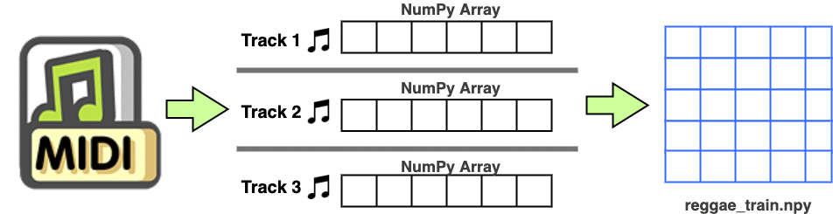

FIG 1. FLOW CHART

The Million Song Dataset was used to produce a random subsample of 10,000 songs in HDF5 format [3]. Using the specified song title and artist information from these HDF5 files, custom code was written to get the corresponding lyrics from LyricWikia [2]. Songs with no lyrics — either instrumental or not in the LyricWikia database — were omitted from the dataset. To compare various feature extraction and preparation procedures, it was necessary to access the lyrics in an unprocessed format using the musiXmatch dataset. Custom Python code based on the NLTK library [5] was developed to detect non-English lyrics and remove them from the dataset using majority support based on the counts of English words vs. non-English keywords in the lyrics. After applying those filtering techniques, the residual dataset of 2,773 songs was randomly split into training dataset (1,000 songs) as well as a validation data (1,000 songs) (200 songs). Music labels were derived automatically from user-supplied content on the song database Last.fm [1]. Because the bulk of the songs in the filtered data lacked atmosphere tags, the two tone labels (happy or sad) were assigned manually due to human interpretation of a lyrics and listening tests. Happy music was defined as music with elevating sounds and pleasant themes. The author described sad music as music related with a bad, dismal, or violent theme.

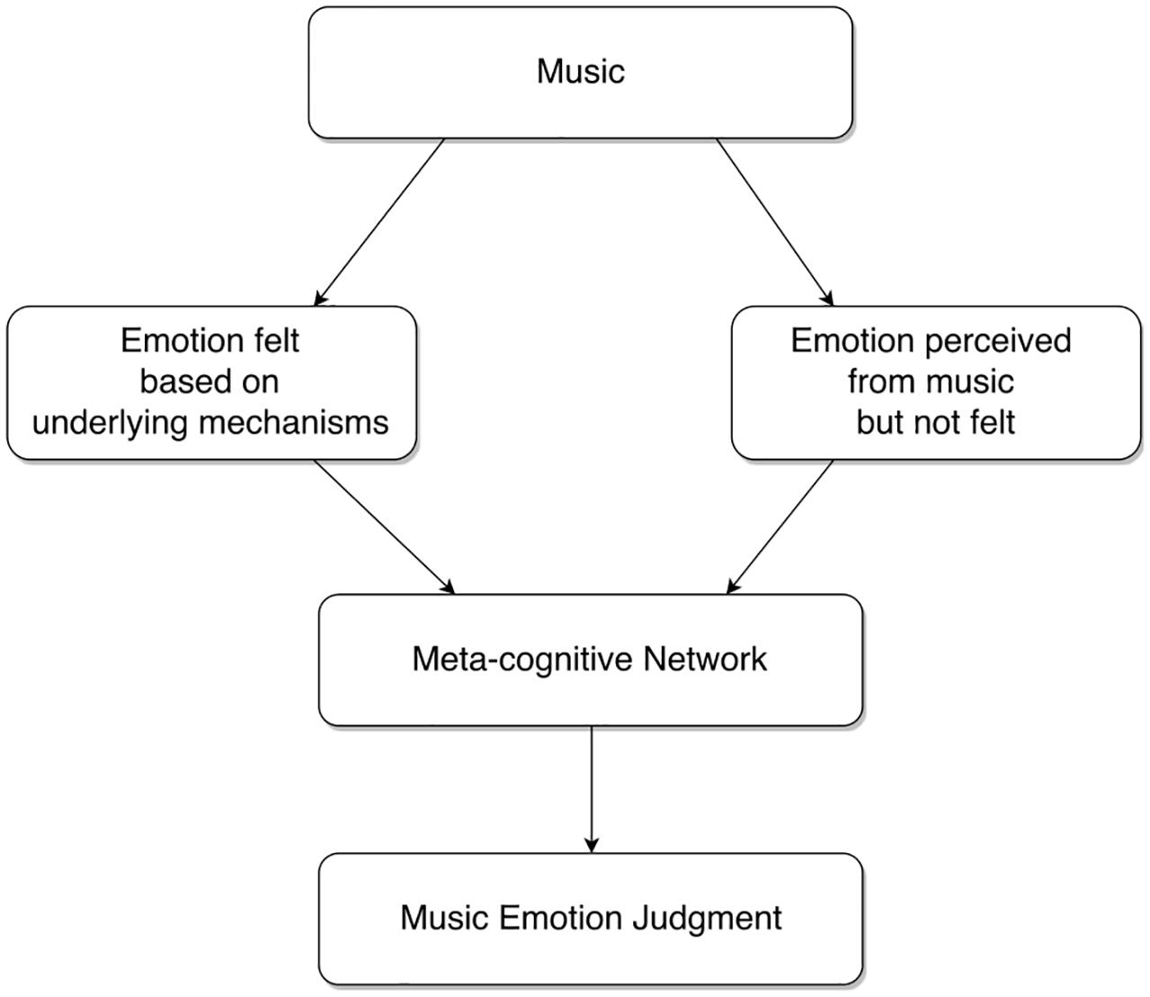

FIG 2. BLOCK DIAGRAM OF THE SYSTEM

We do have the data in the right format because we are utilising a csv file. Classifier, also known as principal selection, aids the model in achieving the intended results. When developing a machine learning technique, it is critical to pick a strong collection of features that will assist us in more accurately anticipating the proper conclusion. Filter techniques, hybrid approaches, embedding methods, & hybrid approaches are the 4 kinds of feature selection algorithms used in machine learning. We employed Random Forest Importance, an embedded approach technique. We found the top 20 parameters that had the most influence on the output label using random forest significance. We also trained and tested another collection of classifiers using all of the information except the audio's name and length. The dataset is then partitioned in an 80:20 ratio, with the training set receiving 80% and the test set receiving 20%. Following that, the information is scaled. Because we want our testing results to be entirely new towards the model and bias-free, we scaled the test and training data independently. Scaling the training sample yields scaling parameters such as mean and standard deviation, which are then applied to the test data. The fundamental purpose of scale the data is to avoid the model from being biassed to a certain element of the dataset. This data is presently being used to train our classifiers..

1. **RESULTS AND DISCUSSION**

The findings mostly suggest that even a for all kinds of reasons naive Bayes model that used mood classifier - based lyrics may accurately predict the pretty positive class (glad), which may be beneficial for filtering a large music collection for cheerful music while reducing the kind false positives, which is fairly significant. A music collection that has been specifically filtered in this manner would be used as input to genre categorization, allowing music to be specifically filtered according to various tastes, or so they believed. Future work will entail integrating more ROC curves of multiple lyrics classification methods to the moods identification web service, which will also be verified using 10-fold cross-validation here on lyrics training dataset, which is thought to consist of 1,000 random songs. The real absolutely positive rate was calculated using songs that were correctly labelled as cheerful, whereas the essentially false sort of positive rate was calculated using songs that were wrongly classed as joyous. In a considerable way, our study was conducted predominantly with Python 3.7 as the programming language. demonstrating how the findings kind of imply that a naive Bayes model applied to mood categorisation based lyrics may effectively forecast the very positive class (happy), that might primarily be beneficial for filtering a large music selection for cheerful lyrics while reducing false positives, or so they thought. Several packages, including Scikit-learn, Pandas, Matplotlib, and others, have been heavily used in our code. For our research, we focused solely on the lyric dataset, which is unquestionably substantial. We obtained the following outcomes in a huge manner after utilising Decision Tree and certainly Random Forests Algorithms to train an algorithm our Mood Prediction model. The count vectorization approach as well as the TF-IDF vectorization model were both used extensively. This machine learning technique was used to categorise lyric mood as "sad" or "glad." The findings suggest that, for the most part, the Random Forest algorithm is capable of accurately predicting lyric mood. The TF-IDF encoding and beautiful Random forest, in example, have a general accuracy of 72.68 percent, or so they believed.

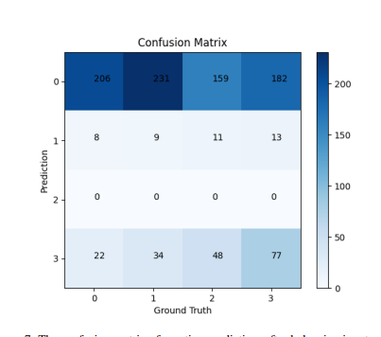

Figure : The confusion matrix of emotion prediction, after balancing input samples

1. **CONCLUSION**

We handled the challenge of identifying musical mood in this study by evaluating lyrics and acoustic data using supervised learning methods and reasoning. Deep learning system implementations have been proposed in combination with several data representations based on the natural language processing and digitizer processing techniques. The procedure was finished with the training and assessment of the three suggested systems—lyrics only, audio only, and multi-modal. The experimental approach validates the basic hypothesis: multi-modal systems outperform uni-modal systems. In the case of recognising the mood created by music, that both lyrics and indeed the audio include relevant information for building deep learning models. The results demonstrate some emotion uniformity in playlists, implying that emotion identification generates useful information for developing Recommender Systems. The short dataset size limits the model's training. With more datasets, more complicated and successful categorization algorithms would be conceivable. This method literally is commonly used to filter a huge music collection for happy music with a low very false generally positive rate, so this method really is commonly used to filter a huge music collection for happy music with a very low very false positive rate in a subtle way. In the future, our classifier will really be developed on a web platform to for all intents and purposes include a wider range of Music Information databases.

1. **FUTURE WORK**

Future work can indeed be accomplished in a variety of ways. The first, and most importantly, direction concerns the amount of the dataset required for the effective creation of a strong deep learning system. Because the data we utilised in this study was restricted, future work would entail designing a system that executes unsupervised learn from unlabeled data, which is abundant. A better alternative for improvements would be to combine vast volumes of unlabeled and modest amounts of labelled data to create systems that include semi-supervised and/or ego learning techniques. In terms of data, using data with lyrics and music aligned will bring significant value and robustness. r. Future study might also rely on a database containing labels reflecting the degree of ambiguity of a track's mood, since we know that listener variability can be large in some circumstances. Such databases would be especially useful for delving deeper into musical emotion. Temporarily localised labels in sufficient quantities may also be of importance. Unsupervised pretraining of deep learning models might be used in future studies, as unlabeled data is easier to locate in large quantities.

1. **REFERENCES**
2. Erion C¸ ano and Maurizio Morisio. Music mood dataset creation based on last.fm tags. In International Conference on Artificial Intelligence and Applications (AIAP), 2017.
3. Tianqi Chen and Carlos Guestrin. Xgboost: A scalable tree boosting system. In 22nd ACM International Conference on Knowledge Discovery and Data Mining (KDD), 2016.
4. Michael Fell and Caroline Sporleder. Lyrics-based analysis and classification of music. In 25th International Conference on Computational Linguistics (COLING), 2014.
5. Youngmoo E. Kim et al. Music emotion recognition: A state of the art review. In 11th International Society for Music Information Retrieval Conference (ISMIR), 2010.
6. Owen Craigie Meyers. A mood-based music classification and exploration system. Master’s thesis, Massachusetts Institute of Technology, 2007.
7. Jeffrey Pennington, Richard Socher, and Christopher D. Manning. Glove: Global vectors for word representation. In Conference on Empirical Methods in Natural Language Processing (EMNLP), 2014.
8. Ashequl Qadir and Ellen Riloff. Learning emotion indicators from tweets: Hashtags, hashtag patterns, and phrases. In Conference on Empirical Methods in Natural Language Processing (EMNLP), 2014.
9. Hassan Walaa, Medhat Ahmed and Korashy Hoda. Sentiment analysis algorithms and applications: A survey. Ain Shams Engineering Journal, 1994.
10. ] Miller, John W, “A Python Client for the Genius.com API.” LyricsGenius, 2020, https://lyricsgenius. readthedocs.io/en/master
11. Richardson, Leonard. “Beautiful Soup Documentation.” Beautiful Soup Documentation - Beautiful Soup 4.9.0 Documentation, 2004, https://www.crummy.com/software/BeautifulSoup/bs4/doc/#
12. Google Colab, Google, https://colab.research.google.com/?utm_source=scs-index